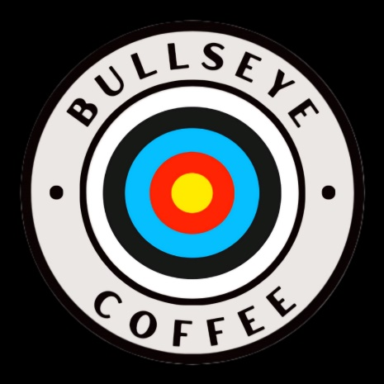

**Specialty Gourmet Coffees**

**Regular Roasts**

**Custom Team/Mascot Flavor –** Medium Roast – Smooth, Rich, and Balanced

**Bullseye Blend –** Dark Roast – Bold, Dark, and Strong

**Flavored Coffee Options**

**The Perfect 50 –** Butterscotch, Vanilla, and Caramel

**The Robinhood Roast –** Warm Vanilla, Smooth, and Nutty

**Nocked and Loaded –** Vanilla, Caramel, and Dark Chocolate